Unit 8 Assignment 2 – Odysseas Latos

**Second Game**

[3]

[2]

[1]

[6]

[7]

[5]

[4]

This is the main page of unity where the game is displayed with all the information. [1] This is the side panel when is shown when you select a subject displaying relevant information to that subject such as size, colour, components etc. [2] This is where you can play your game by pressing play or stop the testing to alter something. [3] This is the scene selector where you can switch from scene to game which is what the player will see but scene is what the developer will see which makes the game playable. [4] This is the other side panel which is displays all the current subjects added to your game and where you can add any new subjects. You can also see subcategories under certain subjects such as super parent, parent which have multiple subjects under it for them to spin together. [5] This is where you can see the folders made for the game such as materials which is how you add colour to your objects. [6] This is where the buttons for this game are placed allowing the player to tilt the maze left or right. [7] That’s the main screen for any game you will be working on.

[2]

[1]

[1] This is where you can make changes to the walls by moving in the x,y or z direction while looking at it the same time. [2] This is where the size of the walls is, you can also add a collider which creates an invisible barrier for the player that they can’t see but they can’t walk through.

This is the sphere/player tab where you change the size and the shape as well as the texture of the sphere. I have added a rigidbody which is needed in order to allow the ball to take the affect of gravity and I have locked the Z position for the ball to stay in the maze and not roll out. The mass of the ball is very light for the ball to spin in the maze without freezing the maze. As you can see the use gravity box is ticked for gravity to take effect.

[1] This is the super parent where it’s the second constant force that works against the parent for the maze to spin in either direction. [2] This is the component that is used in order to rotate the maze which is known as constant force.

[2]

[1]

[2]

[1]

[1] This is the parent tab which includes all the walls, obstacles and glass panel. [2] This is the panel which contains the same attributes as the super parent such as constant force and rigidbody.

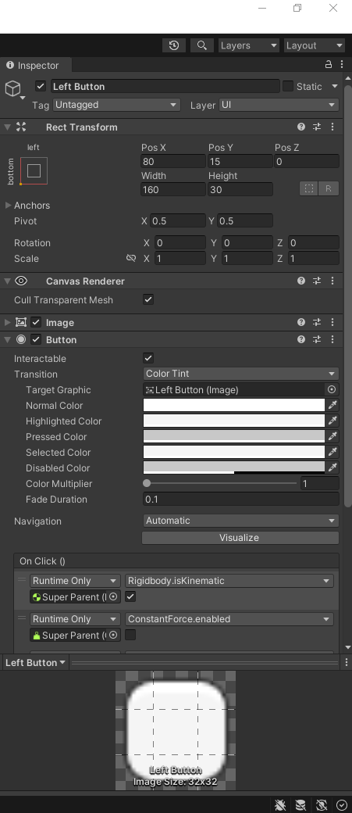

[1]

[2]

[4]

[3]

[1] This is the alignment where you can place the button based on the pre-sets that are available. [2] This is where you can manually change the position of the button. [3] This where you can write the text inside the button. [4] This is where you can change the colour of the text and the box that is inside text.

[1]

[2]

[1] This is where you name the subject. [2] This is where you can change the material of the glass. [3] This is the box collider where you can create an invisible barrier.

**Review of Game:**

Game is fun to play, it has a challenge to it, so it isn’t super easy to pass. The game has easy to understand and simple controls. To improve further, the game can have a longer maze or traps so players can fail so they must restart again, also have a background as it looks quite blank and plain, and a basic solid colour background would make it more visually appealing. One way to improve this game could be by adding some detail to the maze itself perhaps making it look like ancient Greek by changing the walls of the maze into pillars. Changing the ball into something more creative such as a boulder which can make it more interesting. Could also add levels with different mazes progressively getting more difficult by the level. Also add a background instead of they plain grey current background. Based on different devices it would have different controls, for example

**Flowchart:**

No

Yes

**Third Game:**

[1]

[3]

[2]

[5]

[4]

[1] This is the side panel where you can find the main camera, game text, button, input field, place holder, event system and game logic which all play a very important role in the main game. [2] One crucial part of the game is game logic which is the script behind the game almost like the brain of the operation. [3] This is the main game which includes a place to type the number, the select button and the new text which shows what the range is between the different numbers and if you need to go higher, lower or if you got it correct. [4] This is where you select the colour of the background. [5] Is where you select the position of the background.

This is the input field do which is where you enter your number which is a text box in the middle that take input and gives you an output. On the side you can change colour of the text box and the text inside the box along side the size of the text box.

[1] This is where you can change the text of the placeholder which maintains the numbers. [2] Is where you can change the font and size of the text. [3] This is where you can change the material of the place holder to alter the look.

[3]

[2]

[1]

[1]

[2]

[3]

[4]

[5]

[6]

[1] Is a variable that is connected to text box where you enter information, this line of code hold information. [2] This tells the game to generate a random number from 1 to 20 to let the game play and tell the player to right a number down. [3] Is responsible for an output after you enter your number, once you click on the button when the number is entered. [4] Is responsible for letting you know if you are correct. [5] If you got the number wrong the code will tell the person if they need to go higher or lower. [6] This is what is displayed after an answer is entered to tell you to enter a number once you finished.

Review of Game:

The game is very fun and has a repeated fun cycle of trying to guess the number and it can really catch you attention, but it can become repetitive after a while. A way to improve it is to add a bit of a challenge or a better UI which can kind of look like a casino slot machine which can be more visually appealing.